**Christopher King**

**2018141521058**

**Applied Fluid Mechanics**

**Class Section 01**

**04/13/2021**

# **Problem 9.4**

**Solution:**








# **Problem 9.10**

**Solution:**

The boundary conditions for the laminar boundary-layer velocity profile is

When ,

which satisfies the boundary condition.

When ,

which does not satisfy the boundary condition.

# **Problem 9.32**

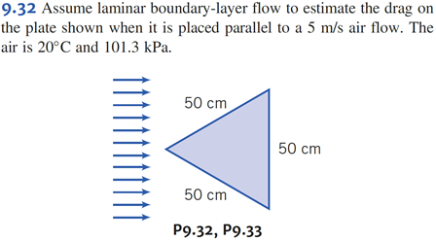

**Solution:**

Therefore, the flow is laminar.

# **Problem 9.33**

**Solution:**

Therefore, the drag is larger than that of Problem 9.32.